1. Write a SQL Statement to create a database.

**Code:**

create database Learning;

**Output:**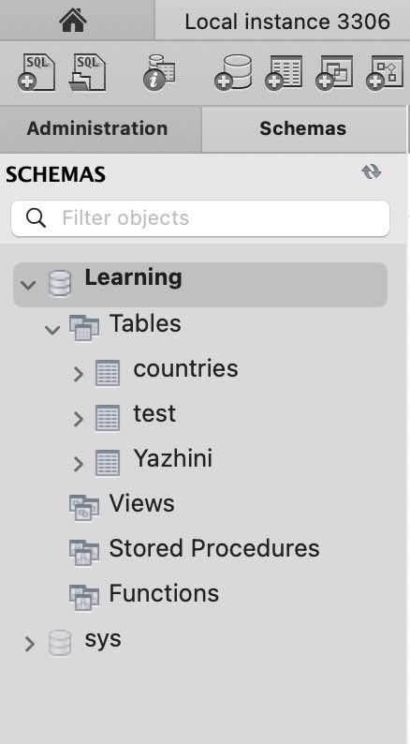

2. Write a SQL statement to create a table named countries including columns country_id,country_name, and region_id, and make sure that no duplicate data against column country_id will be allowed at the time of insertion.

**Code:**

create Table countries (

Country_id varchar (2),

Country_Name varchar (15),

region_id varchar (200),

Unique (country_id)

);

**Output:**

3. Write a SQL statement to create a table named jobs including columns job_id, job_title, min_salary, and max_salary, and make sure that the default value for job_title is blank and min_salary is 8000 and max_salary is NULL will be entered automatically at the time of insertion if no value assigned for the specified columns.

**Code:**

Create table jobs (

job_id int (30),

job_title varchar (30),

Min_salay int default '8000',

Max_salary varchar (255) default 'null',

unique ( job_id)

);

select * from jobs

**Output:**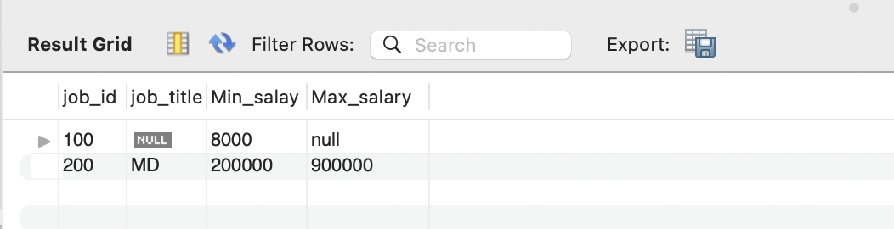

4. Write a SQL statement to create a table employee including columns employee_id, first_name, last_name, email, phone_number hire_date, job_id, salary, commission, manager_id, and department_id

**Code:**

create table employee (

employee_id int (255),

first_Name longtext,

last_name longtext,

email varchar (255),

phone_number int (20),

hire_date date,

job_id int (255),

salary decimal (60,5),

commisssion varchar (255),

Manager_id int (255),

department_id Varchar (255),

unique (employee_id),

unique (email),

unique (phone_number)

);

**Output:**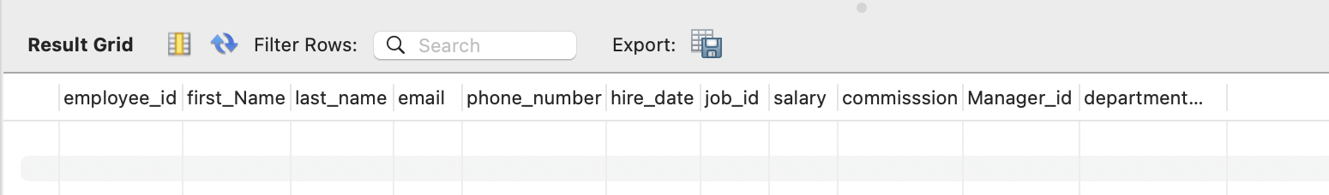

5. Write a SQL statement to insert a record with your own value into the table countries against each column.

**Code:**

insert into countries

Values ( 'Us', 'America', 'west');

insert into countries

values ( 'IN', 'India', 'North'),( 'Br', 'Brazil', 'North');

SELECT * FROM countries;

**output:**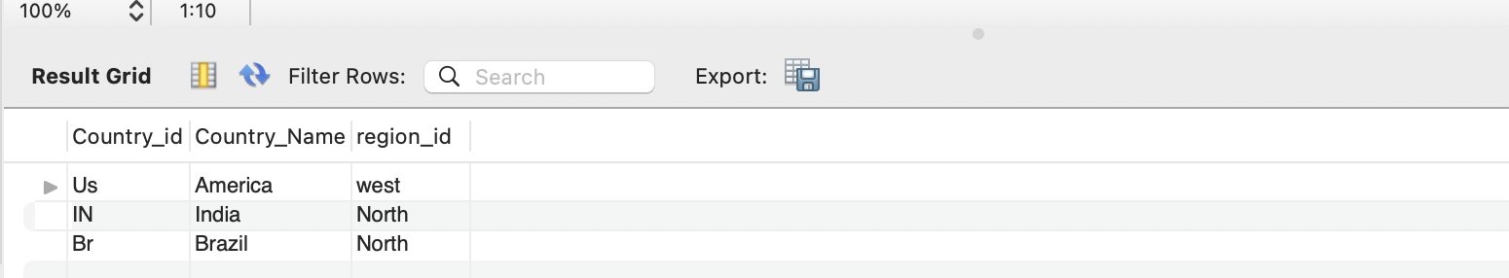

6. Write a SQL statement to insert a record with your own value into the table jobs against each column.

**Code:**

insert into jobs (job_id) value ( '100');

insert into jobs value ('200', 'MD', '200000', ‘900000’);

select * from jobs

**Output:**

7. Write a SQL statement to insert one row in the jobs table to ensure that no duplicate value will be entered in the job_id column.

**Code:**

alter table jobs

add job_name varchar (200);

select * from jobs;

alter table jobs

drop column job_name;

alter table jobs

add job_name varchar (200) after job_id;

alter table jobs add unique (job_id);

**Output:**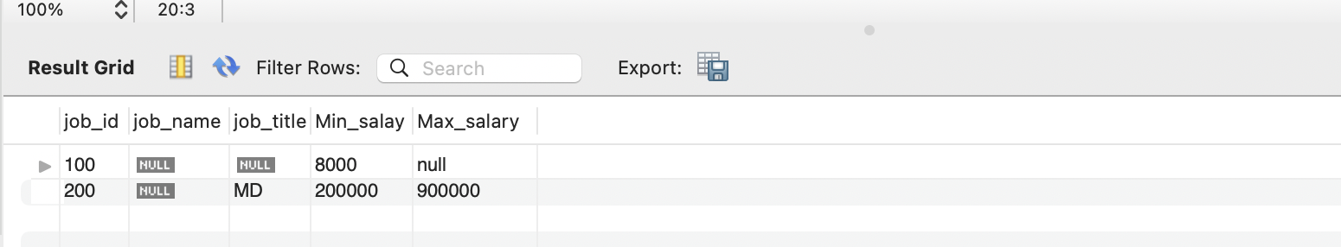

8.Write a SQL statement to rename the table countries to country_new.

**Code:**

rename table countries to country_new

select * from Country_new;

**Output:**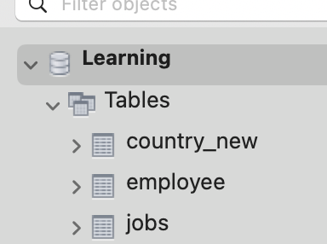

9.Write a query to display the names (country_id, country_name) using alias name “Country ID", "Country Name”

**Code:**

select Country_id as 'Country ID', Country_name as 'country name' from country_new;

**Output:**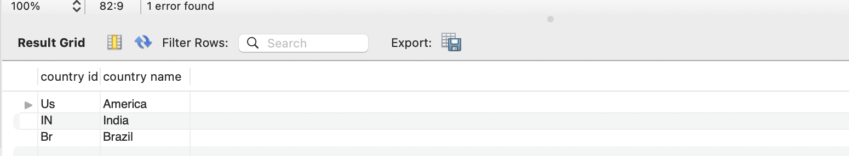

10.Write a query to get all country details from the countries table order by country_name, descending.

**Code:**

rename table Country_new to Countries;

select * from Countries order by Country_name desc;

**Output:**